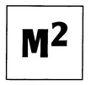
PRESENTS

ARTS CABARET 17
in JJ Harlow’s Bar The Square Roscommon
on FRIDAY 21st SEPTEMBER at 7.00pm
also FAXBOX PROJECT
PERFORMANCE POETRY
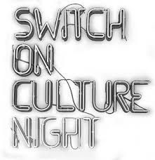
●RÓISIN POWER ●DYMPNA MOLLOY
HACKETT ●JAMES MORAN
●NOEL MOLLOY
SONG READING
●DECLAN COYNE ●PATRICK ANDERSON
S.R.S.C. MCQUOID
●LORNA BRENNAN ●FRANK CARROLL
VIDEO MUSIC
●PATRICK ANDERSON ●TRADITIONAL
MCQUOID ●ALSO COURTESY
●NOEL MOLLOY JJ HARLOWS
ADMISSION FREE ALL ARE WELCOME
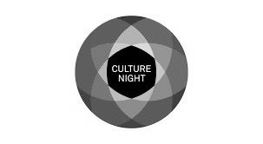
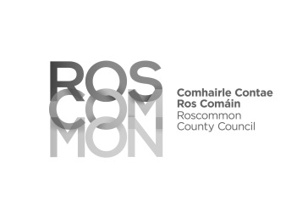
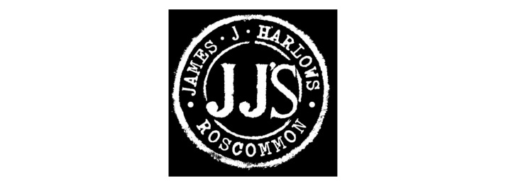
VIDEO PREMIERE ‘PRISM OF FREEDOM’ PLUS ‘WALL’ BY NOEL MOLLOY

